LegendRise™
PRODUCT REQUIREMENTS DOCUMENT
Career & Venture Progression Platform
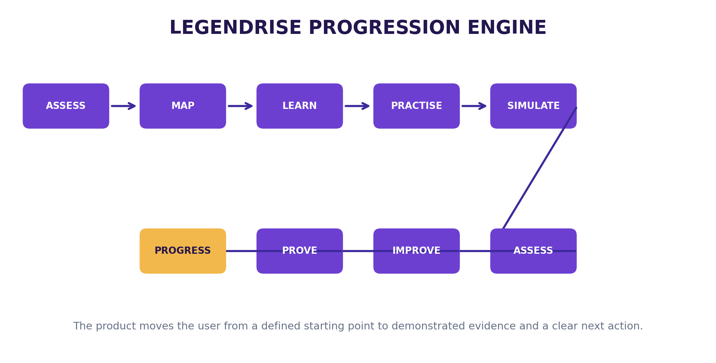
Figure 1. LegendRise's core progression loop, based on the supplied product playbook.
CORE PRODUCT PROMISE
Choose what you want to become or build. LegendRise assesses where you are, maps the route, teaches what you need, lets you practise, evaluates your work and continuously tells you what to do next.

Version 2.0 • Comprehensive product roadmap • September 2026
Prepared from the supplied LegendRise™ — Start-to-Finish Product Build Playbook. Additional requirements are explicitly marked as product proposals or validation items.

DOCUMENT MAP
• 1. Executive Product Definition
• 2. Source Boundary and Evidence Discipline
• 3. Product Strategy and Architecture
• 4. Target Users and Jobs to Be Done
• 5. Product Principles and Non-Negotiables
• 6. MVP Scope and Release Boundaries
• 7. End-to-End Career Journey
• 8. End-to-End Venture Journey
• 9. Detailed Functional Requirements
• 10. Resource and Content System
• 11. AI Intelligence Architecture
• 12. Assessment, Evidence and Portfolio
• 13. UX/UI and Screen Requirements
• 14. Technical Architecture and Integrations
• 15. Data Model
• 16. Security, Privacy and Responsible AI
• 17. Analytics and Measurement
• 18. Admin, CMS and Operating Model
• 19. Content Production System
• 20. Build and Implementation Roadmap
• 21. Testing and Validation Plan
• 22. Go-Live and Launch
• 23. Monetisation and Commercialisation
• 24. Long-Term Platform Roadmap
• 25. Risks, Dependencies and Decision Register
• 26. Definition of Done
• 27. Appendices and Product Templates
HOW TO READ THIS PRD
This document is intentionally more detailed than the original playbook. The original playbook is the source of product direction; this PRD converts that direction into buildable requirements, acceptance logic, ownership questions and sequencing. Where the source does not establish a fact, this document does not invent one.

1. EXECUTIVE PRODUCT DEFINITION
LegendRise Career & Venture OS is defined in the supplied playbook as a career-and-venture progression system. The user provides a destination; the platform assesses the starting point, maps a route, delivers learning and practice, supports simulation and assessment, preserves evidence and recommends the next action. The playbook explicitly states that the product is the progression engine, not the course library. fileciteturn1file0
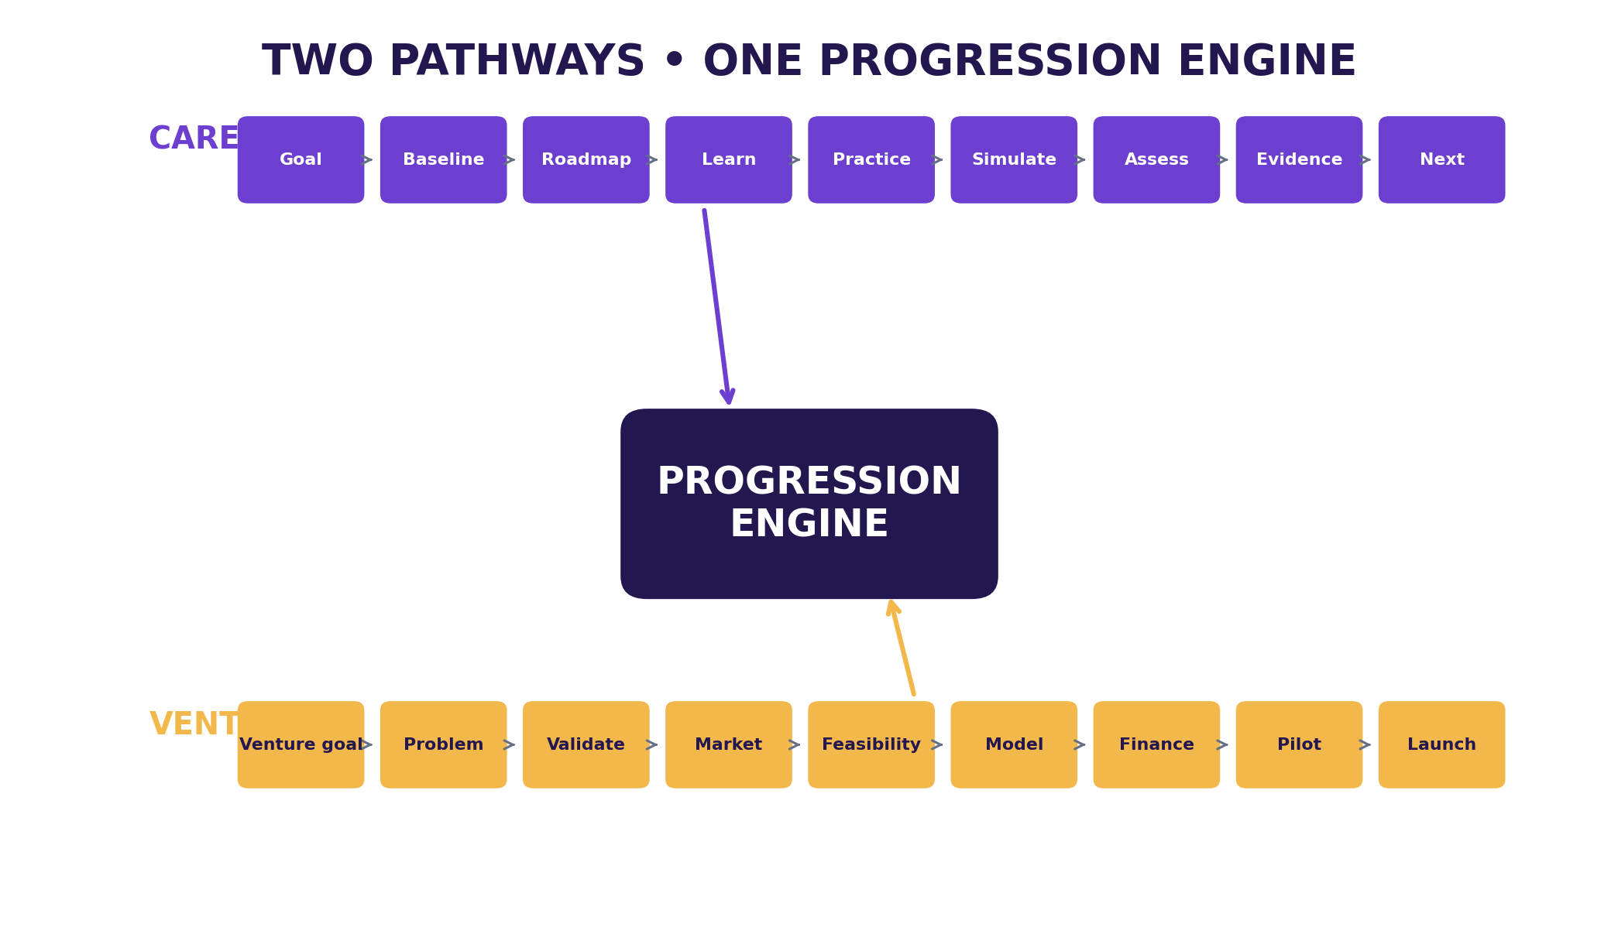
Figure 2. Two connected pathways sharing one progression engine.

1.1 Product definition
Dimension | Career | Venture
Destination | Target role/field and desired level | Business objective and venture ambition
Baseline | Knowledge, skills, experience, confidence | Founder background, idea, resources, customer hypothesis
Roadmap | Skill sequence and milestones | Validation and venture-building sequence
Learning | Short lessons and resources | Business-building lessons and guided tools
Practice | Workplace tasks | Founder experiments and execution tasks
Simulation | AI role-play with client/manager/customer | AI role-play with customer/advisor/stakeholder
Assessment | Rubric-based practical evaluation | Evidence and assumption checks
Evidence | Projects, simulations, portfolio | Validation findings, model, financial logic, pilot evidence
Next action | Recommended next skill/task | Recommended next experiment/action

1.2 Strategic positioning
The playbook's positioning direction is not based on claiming that AI coaching, practical projects or venture-building are new. It states that adjacent products already combine these elements and therefore LegendRise needs a sharper value proposition and disciplined MVP. The proposed strategic move is continuous progression toward a defined outcome. This is a differentiation hypothesis that requires validation, not an established market fact. fileciteturn3file7
Strategic move | LegendRise direction
Eliminate | Course completion as the primary success measure
Reduce | Long passive lectures and unnecessary content
Raise | Personalisation, practical work, feedback, continuity and evidence
Create | A progression engine connecting learning, practice, assessment, portfolio/evidence and next actions

2. SOURCE BOUNDARY AND EVIDENCE DISCIPLINE
The primary source for this PRD is the uploaded “LEGENDRISE CAREER & VENTURE OS — START-TO-FINISH PRODUCT BUILD PLAYBOOK.” The source establishes the core promise, two pathways, MVP scope, user journeys, screen blueprint, proposed technology stack, AI services, data model, validation plan, build sequence, launch checklist and long-term roadmap. fileciteturn3file3
Label used in this PRD | Meaning
SOURCE-SUPPORTED | Directly grounded in the supplied playbook.
PRODUCT PROPOSAL | A logical extension introduced to make the PRD more complete; it must be validated before being treated as final.
VALIDATION REQUIRED | An assumption that should be tested with users, buyers, experts or product data.
IMPLEMENTATION CHOICE | A technical/design decision that may change without changing the product concept.

NO-HALLUCINATION RULE
No career requirement, salary, certification, employment outcome, funding outcome, market statistic or external claim should be invented by the product. The playbook specifically requires grounded content, explicit uncertainty and no unsupported claims. fileciteturn3file6

3. PRODUCT STRATEGY AND ARCHITECTURE
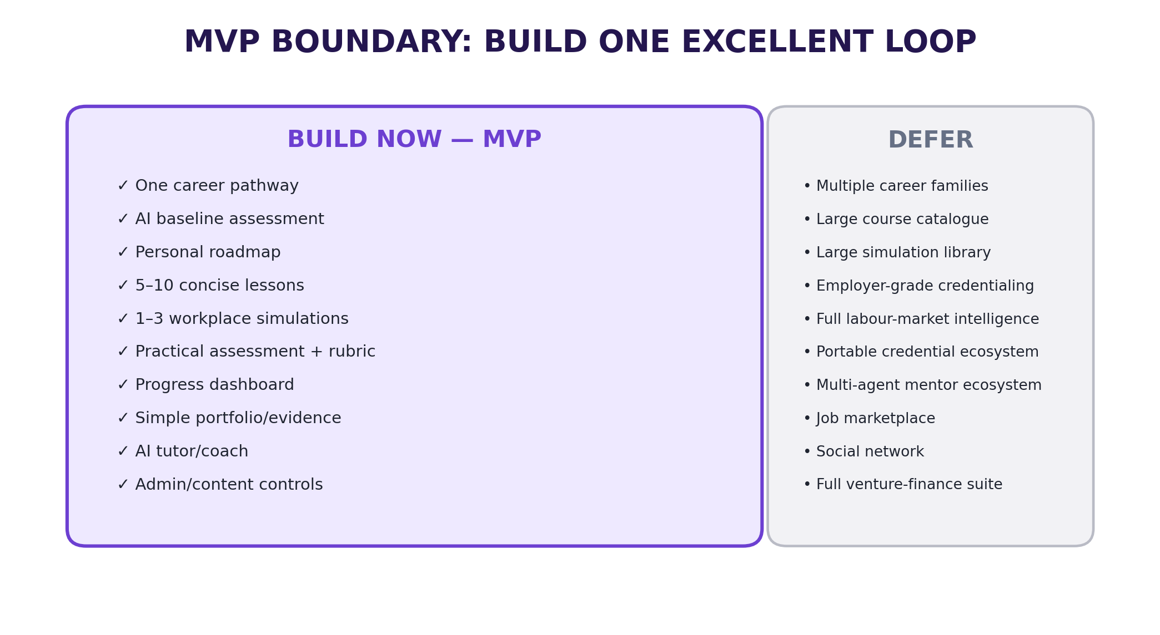
Figure 3. MVP boundary derived from the supplied scope-control rules.

3.1 Shared progression architecture
The architecture should support both pathways without forcing the first release to build the complete venture experience. The playbook's MVP rule is explicit: build one complete career pathway first, while keeping the architecture ready for Venture. fileciteturn3file3

3.2 Product layers
Layer | Core responsibility | MVP status
Experience | Learner/admin interfaces | Build
Destination | Career goal or venture goal | Build
Baseline | Starting-state diagnostic | Build for Career
Roadmap | Ordered milestones and actions | Build
Learning | Lessons and resources | Build
Practice | Realistic work tasks | Build
Simulation | AI role-play | Build one high-quality scenario
Assessment | Rubric-based evaluation | Build
Evidence | Portfolio/capability evidence | Build
Next action | One clear next step | Build
Venture Lab | Founder validation and execution | Architecture + later release

4. TARGET USERS AND JOBS TO BE DONE
The playbook identifies three initial target groups and explicitly warns against starting with every career, age group and founder type. fileciteturn3file7
Priority | User | Problem to test
P1 | Early-career Nigerian professional/graduate | Knows the career direction but may not know the sequence of skills, practice and evidence needed to progress.
P2 | Aspiring small-business founder | Has an idea but needs structured validation, feasibility, numbers and execution guidance.
P3 | Working professional changing/upgrading career | Needs targeted gap closure rather than another general course library.

4.1 Validation questions
• What were you trying to achieve before using LegendRise?
• What part of the journey was hardest before this product?
• What did LegendRise help you do that a normal course did not?
• Which part felt most useful: learning, practice, simulation, feedback or roadmap?
• What would make you stop using it?
• Would you pay for the complete journey? What would you expect in return?
These questions are reproduced from the supplied validation plan and should be used as research prompts rather than as evidence that the problem has already been validated. fileciteturn2file4

5. PRODUCT PRINCIPLES AND NON-NEGOTIABLES
• The product is the progression engine, not the course library.
• Every major learning item should connect to a milestone and a practical outcome.
• Assessment should rely on explicit rubrics and sufficient evidence.
• AI should be separated into testable services rather than one giant prompt.
• High-impact progression decisions should have deterministic rules around the model.
• The tutor should be grounded in approved LegendRise curriculum content.
• The platform should make uncertainty visible where evidence is insufficient.
• Do not build the ecosystem before the core progression loop works.
• Collect only information necessary for the journey and protect private records.
• Do not represent AI output as guaranteed career, salary, employment, funding or business outcomes.
These principles are directly aligned with the playbook's product, AI, privacy and MVP rules. fileciteturn2file6

6. MVP SCOPE AND RELEASE BOUNDARIES
Build now | Build later
One career pathway | Multiple career families
AI baseline assessment | Advanced psychometrics
Personal roadmap | Full adaptive learning graph
5–10 concise lessons | Large course catalogue
1–3 workplace simulations | Large simulation library
Practical assessment + rubric | Employer-grade credentialing
Progress dashboard | Full labour-market intelligence
Simple portfolio/evidence | Portable credentials ecosystem
AI tutor/coach | Multi-agent mentor ecosystem
Venture architecture | Full Venture Lab

The above boundary is source-supported and should be treated as the scope-control baseline. fileciteturn3file7

6.1 MVP entry and exit criteria
Gate | Requirement | Evidence
Entry | One career is selected and frozen for the build cycle | Approved career definition
Entry | First 10 learning/practice items defined | Content inventory
Entry | Core screens specified | Figma/UI specification
Exit | New user can complete the full core flow | Observed end-to-end test
Exit | Assessment produces rubric-linked feedback | Evaluation test
Exit | Evidence can be saved | Portfolio test
Exit | Dashboard shows one clear next action | Usability test
Exit | Real users have tested the product | Validation log

7. END-TO-END CAREER JOURNEY
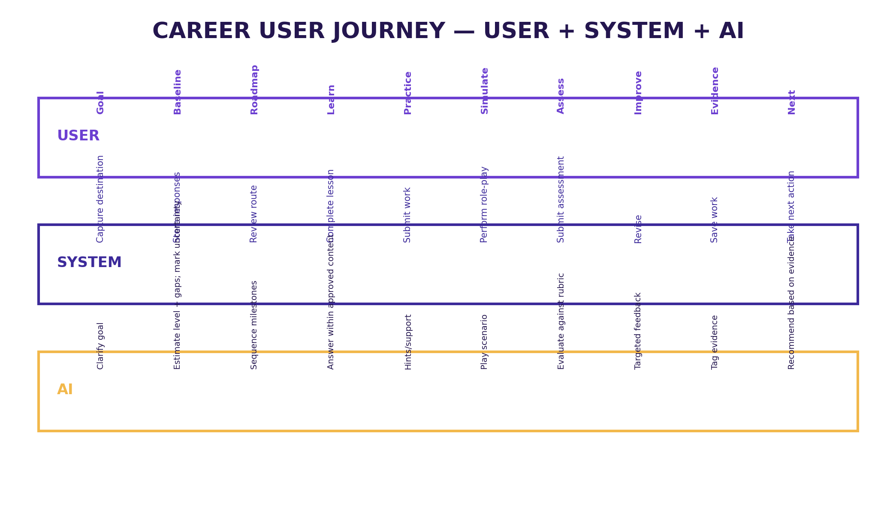
Figure 4. Career journey as a coordinated user, system and AI workflow.
Step | User experience | AI/system responsibility | Output
1. Welcome | Choose Career | Explain journey and collect goal | Goal record
2. Goal | Select/enter target career and level | Clarify destination | Career target
3. Baseline | Complete short diagnostic | Estimate current level/gaps; mark uncertainty | Starting profile
4. Roadmap | Review staged path | Sequence learning/practice | Roadmap
5. Learn | Complete lesson | Answer within lesson context | Learning activity
6. Practice | Complete realistic task | Instructions, hints, relevant resources | Work product
7. Simulation | Perform AI role-play | Act as client/manager/customer | Simulation result
8. Assess | Submit work | Score against explicit rubric | Assessment
9. Improve | Revise/retry | Targeted feedback | Improved submission
10. Evidence | Save completed work | Tag capability and update progress | Evidence
11. Next | Take next milestone | Recommend based on performance | Next action

7.1 Career requirements
ID | Requirement | Acceptance condition
CAR-01 | User can select/enter a career goal | Goal is stored and visible on dashboard
CAR-02 | User can complete baseline | Responses are stored and diagnostic completes
CAR-03 | System creates a staged roadmap | Milestones are ordered and visible
CAR-04 | Lessons support text, narrated media, screen demonstration and downloadable resources | Configured asset types render correctly
CAR-05 | Practice task includes brief, workspace, hints and submission | User can submit work
CAR-06 | Simulation has defined scenario, AI role and task | User can complete and finish scenario
CAR-07 | Assessment uses explicit rubric | Score and feedback map to criteria
CAR-08 | User can retry where configured | New submission/version is stored
CAR-09 | Completed work can become evidence | Evidence record links to work
CAR-10 | Dashboard shows one obvious next action | Next-action control is visible and actionable

8. END-TO-END VENTURE JOURNEY
The venture pathway is source-supported as a later platform layer. The playbook defines a sequence from venture goal through problem, customer validation, market, feasibility, business model, financial logic, business plan and pilot. fileciteturn3file0
Stage | Founder action | Platform output
1. Venture goal | Describe idea and target customer | Structured idea brief
2. Problem | Define customer problem | Problem hypothesis + test questions
3. Customer validation | Conduct guided interviews/tests | Interview guide + evidence log
4. Market | Research competitors, prices and demand | Structured market evidence
5. Feasibility | Assess operating requirements, constraints and risks | Feasibility workbench
6. Business model | Define value proposition and revenue logic | Business model summary
7. Financial logic | Enter pricing, volume, costs and funding assumptions | Assumptions + scenario view
8. Business plan | Document validated case | Plan assembled from prior evidence
9. Pilot | Run small controlled launch/test | Pilot checklist + learning loop

8.1 Venture evidence rules
• Separate assumptions from evidence.
• Store the source or origin of validation evidence where available.
• Do not let AI convert a plausible statement into a verified market fact.
• Financial outputs should clearly identify assumptions and scenarios.
• Business-plan generation should occur after evidence has been gathered, not as a substitute for validation.

9. DETAILED FUNCTIONAL REQUIREMENTS
ID | Module | Requirement | Priority
FR-001 | Authentication | Email sign-up/login, password reset and basic profile | MVP
FR-002 | Onboarding | Collect goal, current level, experience, preferences and availability as required by the playbook | MVP
FR-003 | Career selection | Select/enter target career and level | MVP
FR-004 | Baseline | Structured short assessment with stored responses | MVP
FR-005 | Roadmap | Data-driven ordered milestones | MVP
FR-006 | Lesson player | Text, narrated media, screen demo, resources, notes and completion | MVP
FR-007 | Resource access | Download/open linked resources | MVP
FR-008 | Practice workspace | Task brief, work area, hints, submission | MVP
FR-009 | Simulation | AI role-play with scenario state and completion condition | MVP
FR-010 | Assessment | Practical task + explicit rubric | MVP
FR-011 | Feedback | Score, evidence, improvement actions | MVP
FR-012 | Retry | Resubmission/versioning where configured | MVP
FR-013 | Progress | Milestone status, scores and evidence | MVP
FR-014 | Portfolio | Public/private evidence page | MVP
FR-015 | AI Coach | Contextual tutor/coach | MVP
FR-016 | Admin | Careers, milestones, lessons, simulations, assessments, rubrics | MVP
FR-017 | Analytics | Core product events | MVP
FR-018 | Venture architecture | Navigation and data objects | MVP architecture
FR-019 | Payments | Plans, checkout, access rules | After validation
FR-020 | Mobile | Expo/React Native client using same backend | Post-web stabilisation

10. RESOURCE AND CONTENT SYSTEM
The supplied playbook already requires downloadable resources within lessons and a repeatable content factory. The following expands that requirement into a controlled resource system.
Resource type | Purpose | Required fields
Guide | Explain a concept/process | Title, description, stage, capability, version, owner, review date
Template | Enable action | Purpose, instructions, format, related task
Checklist | Support execution | Stage, checklist items, version
Worked example | Show how a task can be approached | Context, task, example, limitations
Case study | Connect learning to a scenario | Context, source, learning points
Worksheet | Capture user work | Inputs, instructions, output
Download pack | Bundle milestone assets | Included assets, version
Tool/calculator | Support structured calculation | Inputs, assumptions, outputs

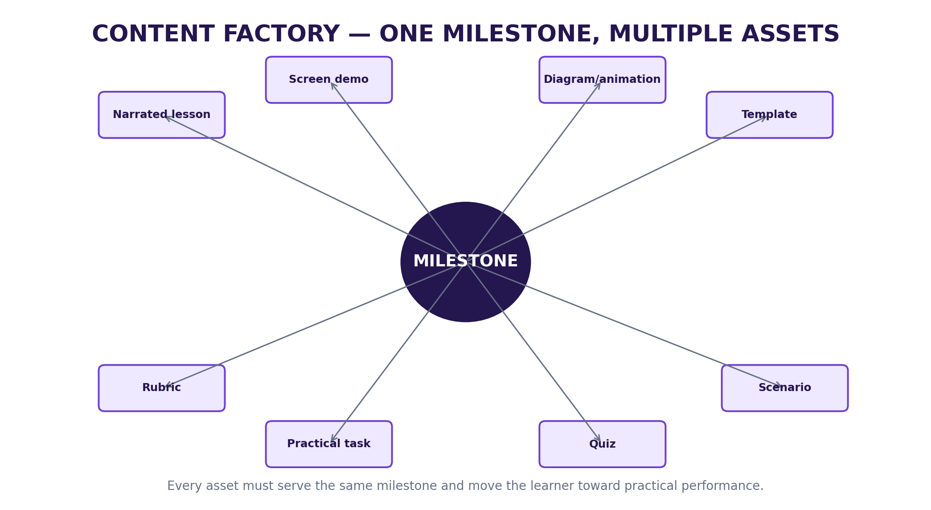
Figure 5. Content factory: each milestone can produce multiple coordinated learning and action assets.

10.1 Resource workflow
Create → Review → Tag → Publish → Link to milestone/task → Track usage → Review performance → Update/archive.

10.2 Founder-created resources
PRODUCT PROPOSAL
Founder-created resources can become a proprietary content asset, but the product should not assume that a large library is valuable before users demonstrate demand. Content should be created in response to validated journey needs.

11. AI INTELLIGENCE ARCHITECTURE
The playbook explicitly states that LegendRise should not use one giant prompt. AI functions should be separate, testable services with explicit inputs and outputs. fileciteturn3file4
AI service | Input | Output | Control
Career assessor | Goal + responses + experience | Structured starting profile + gaps | Defined scoring/uncertainty
Roadmap engine | Starting profile + career template | Milestones + ordered actions | Approved pathway data
Tutor | Current lesson + approved content + question | Grounded explanation | Content grounding
Simulation agent | Scenario + role + rubric + user response | Role response + state + coaching | Scenario boundaries
Assessment evaluator | Submission + rubric | Score + evidence + feedback | Rubric authoritative
Next-step recommender | Progress + scores + unfinished tasks | Next milestone + reason | Evidence-based rule
Venture coach | Venture stage + evidence | Next experiment/decision | Evidence/assumption distinction

11.1 AI request lifecycle
• Identify current product context.
• Retrieve only approved context needed for the service.
• Send structured input to the relevant AI function.
• Validate the output schema.
• Apply deterministic product rules.
• Store the appropriate result and audit information.
• Show uncertainty where required.
• Allow the user to report incorrect output.

11.2 AI non-functional requirements
Requirement | Rule
Secrets | API keys remain server-side
Grounding | Tutor uses approved curriculum/content
High-stakes decisions | AI cannot independently mark required milestones complete
Unsupported claims | No invented job, salary, certification, funding or employment guarantees
Failure behaviour | AI must have explicit fallback/uncertainty responses
Auditability | Important AI decisions/results retain context needed for review

12. ASSESSMENT, EVIDENCE AND PORTFOLIO
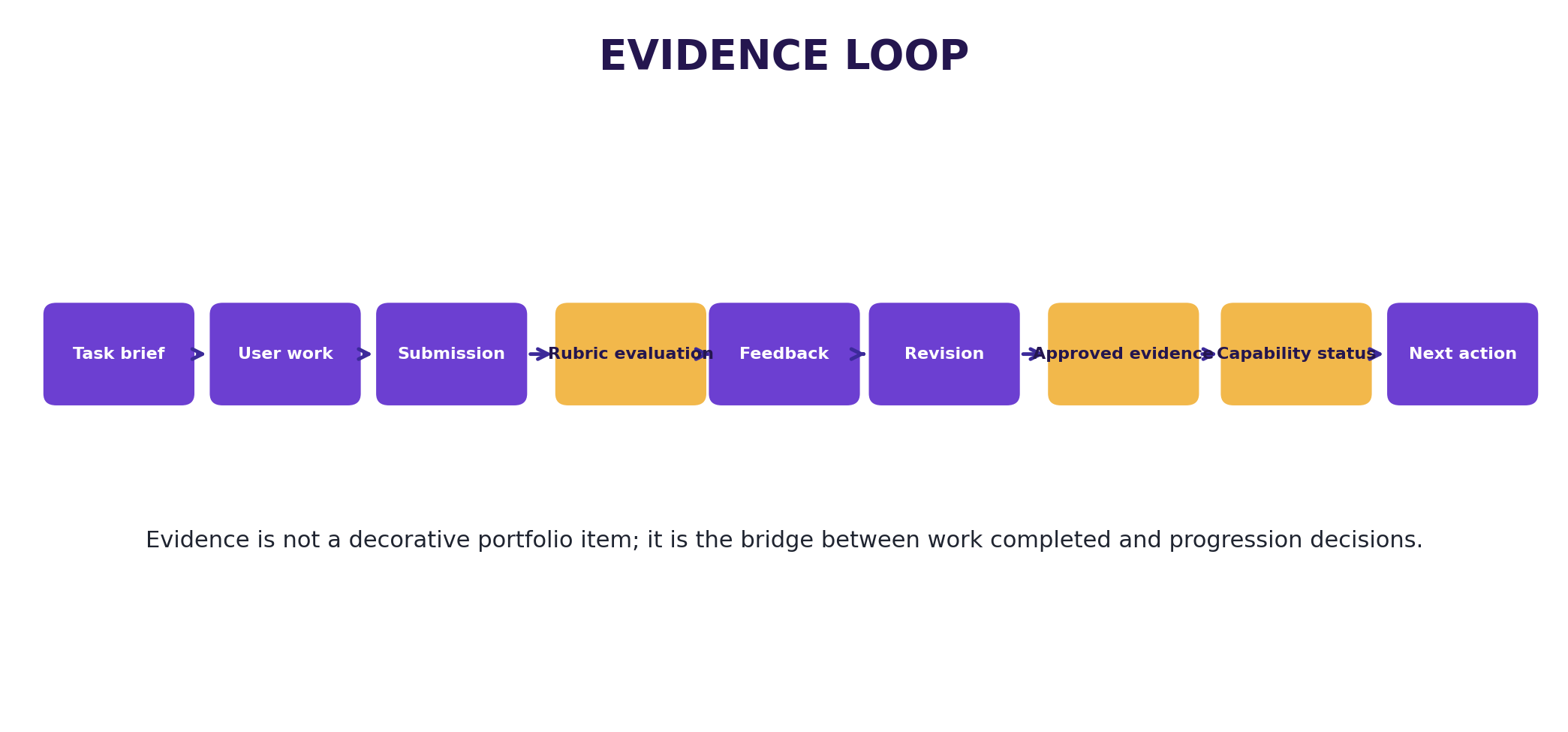
Figure 6. Evidence loop connecting practical work to progression.
Component | Requirement
Task brief | What the learner must produce
Criteria | Observable performance dimensions
Rubric levels | Meaning of each level
Submission | Actual learner work
Score | Criterion-level and/or overall result
Feedback | Evidence-based improvement actions
Retry | Configured resubmission path
Evidence | Saved work that supports capability status

12.1 Capability status
Status | Meaning | Allowed progression behaviour
Not assessed | No sufficient evidence | Do not infer capability
Developing | Some evidence but not yet sufficient/consistent | Recommend targeted practice
Demonstrated | Evidence meets configured rubric | Allow configured milestone progression
Needs review | Ambiguous/exceptional case | Request more evidence or human review

12.2 Portfolio
The playbook calls for a simple public/private evidence page. The portfolio should therefore be an evidence record first, with visual presentation added around the underlying evidence rather than replacing it. fileciteturn3file2

13. UX/UI AND SCREEN REQUIREMENTS
The supplied interface direction is a premium, calm, modern education/productivity experience. The playbook describes clean cards, clear progress states, strong typography, accessible contrast and avoidance of excessive gradients or clutter. fileciteturn3file3
Screen | Purpose | Core components
Landing | Explain value and convert visitor | Career/Venture choice, outcomes, CTA
Onboarding | Understand user | Goal, current level, experience, preferences
Dashboard | Show what matters now | Current path, progress, next action, AI coach, quick actions
Career Path | Show route | Milestones, levels, completed/in-progress/locked states
Lesson | Teach | Player, notes, resources, AI tutor, next action
Practice | Turn learning into work | Brief, workspace, hints, submit
Simulation | Role-play | Scenario, AI role, task, conversation, finish, feedback, retry
Assessment | Measure capability | Task, submission, rubric, score, feedback, evidence
Portfolio | Show evidence | Projects, simulations, certificates, capabilities
Venture Lab | Build/test idea | Problem, customer, market, feasibility, model, finance, plan
AI Coach | Contextual support | Chat, recommendations, explanation
Admin | Operate platform | Users, careers, lessons, simulations, rubrics, analytics

13.1 Dashboard requirement
• Current career/path.
• Current level and progress.
• One recommended next action.
• Continue learning.
• Upcoming assessment.
• AI Coach entry point.
• Portfolio/evidence snapshot.

13.2 Design system
Element | Requirement
Typography | Times New Roman is used for this PRD; product UI may use an accessible product font selected during UI design
Colour | Use the approved LegendRise brand palette with strong contrast
Cards | Use clear hierarchy; avoid decorative clutter
States | Completed, in progress, locked, needs attention and evidence states must be visually distinct
Accessibility | Readable contrast, clear labels, keyboard/touch usability and meaningful error states
Responsive | Core journey must work on desktop and mobile web before native app release

14. TECHNICAL ARCHITECTURE AND INTEGRATIONS
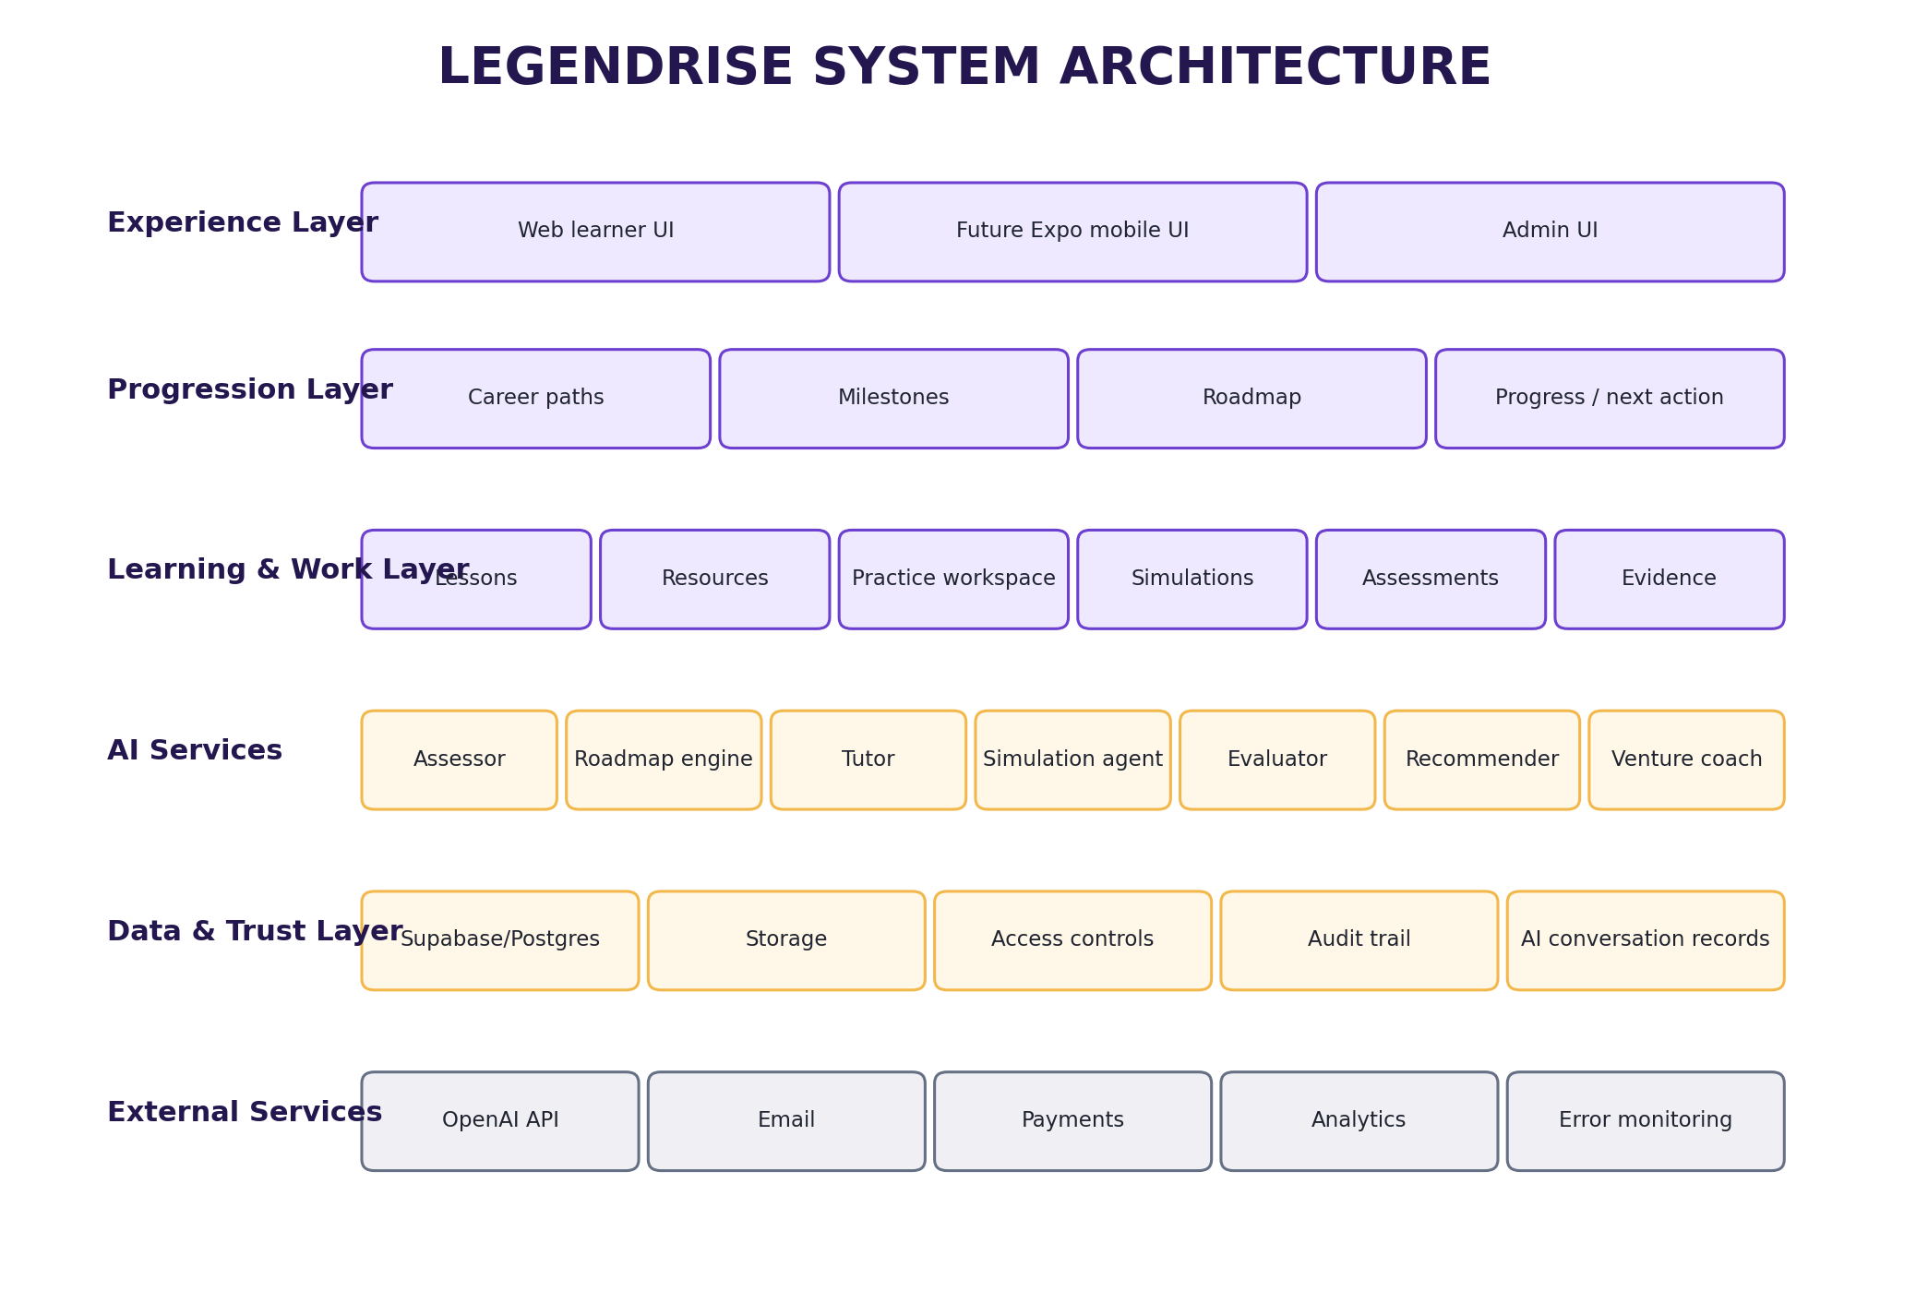
Figure 7. Proposed layered system architecture based on the supplied technical stack and AI design.
The playbook proposes Replit + Replit Agent, Expo/React Native, Supabase, OpenAI API, GitHub, Figma, optional Vercel, Paystack, Resend, PostHog and Sentry. These are implementation proposals and current commercial details should be re-checked before purchasing or launch. fileciteturn3file5
Platform | Purpose | Use in sequence
Replit | Primary build environment | Build MVP
GitHub | Source control/backups | Create immediately
Figma | UI/UX design/specification | Before UI polish
Supabase | Auth, Postgres, storage, security | Core backend
OpenAI API | AI services | Server-side calls
Expo | Native Android/iOS layer | After web stabilises
Paystack | Nigeria payments | After commercial validation
Resend | Transactional email | Verification/reset/notifications
Analytics | Product behaviour tracking | Before public testing
App stores | Public mobile distribution | After validation

14.1 Non-functional requirements
Area | Requirement
Security | Server-side secrets, input validation, row-level access controls
Performance | Core journey should remain usable on ordinary mobile web conditions; exact targets require performance testing
Availability | Production hosting and recovery targets to be defined before launch
Maintainability | Modular services, documented code, data-driven career templates
Scalability | Additional careers should be added through data/content configuration rather than application rewrites
Observability | Analytics and error monitoring should be present before public beta

15. DATA MODEL
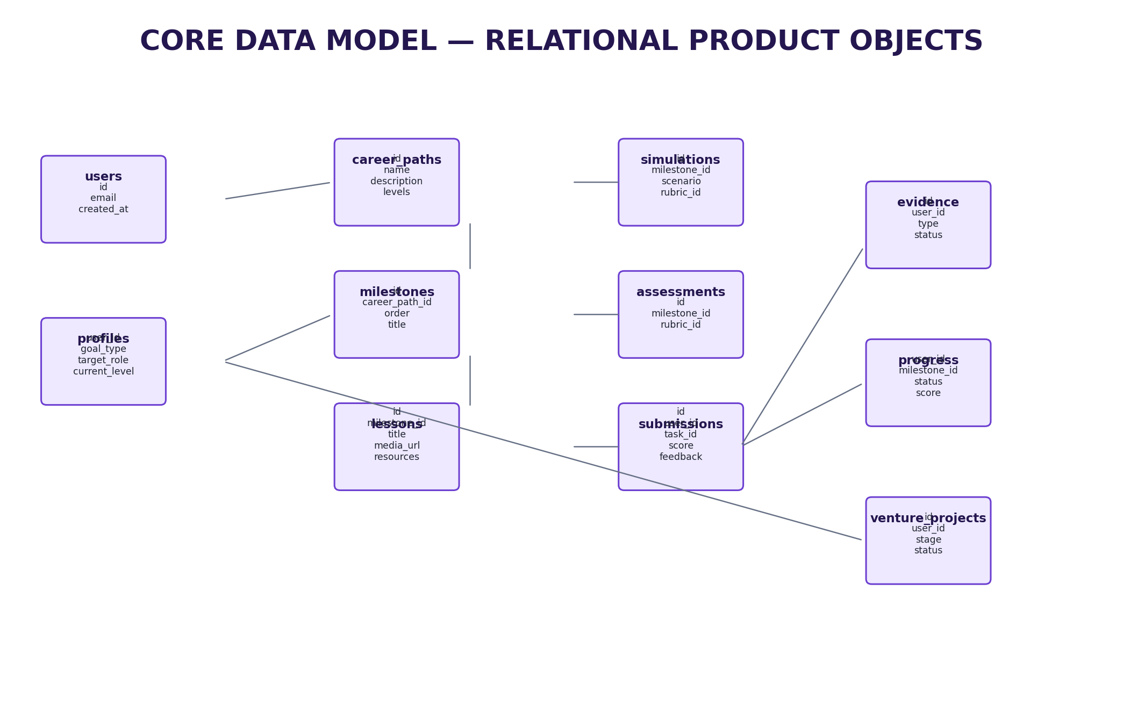
Figure 8. Core relational data objects from the supplied database structure.
Table | Key fields from playbook | Purpose
users | id, email, name, country, created_at | Identity/account
profiles | user_id, goal_type, target_role, current_level | Learner/founder profile
career_paths | id, name, description, levels | Career definitions
milestones | id, career_path_id, order, level, title | Progression stages
lessons | id, milestone_id, title, media_url, text, resources | Learning content
simulations | id, milestone_id, scenario, rubric_id | AI practice
assessments | id, milestone_id, rubric_id | Assessment definitions
submissions | id, user_id, task_id, content, score, feedback | Learner work
evidence | id, user_id, type, title, source, status | Portfolio/capability evidence
progress | user_id, milestone_id, status, score, completed_at | Journey state
venture_projects | id, user_id, stage, status | Founder pathway
venture_evidence | project_id, type, source, result | Validation evidence
ai_conversations | user_id, context_type, context_id, messages | AI interaction history
subscriptions | user_id, plan, status, provider_reference | Later monetisation

The PRD should preserve this data-driven architecture. Any additional tables required during implementation should be documented as implementation extensions rather than silently changing the product model.

16. SECURITY, PRIVACY AND RESPONSIBLE AI
• Collect only information necessary for the user's journey.
• Keep API keys on the server and out of client-side code.
• Use authenticated access to private records.
• Apply row-level access controls to user-owned data.
• Give users a clear way to understand what data is stored.
• Do not present AI outputs as guaranteed career, salary, employment, funding or business outcomes.
• Ground learning and assessment content in approved LegendRise materials and clearly sourced external information.
• Use human review for high-impact content before publishing at scale.
• Provide a mechanism to report incorrect AI feedback.
• Do not build around surveillance, deceptive automation or fabricated credentials.
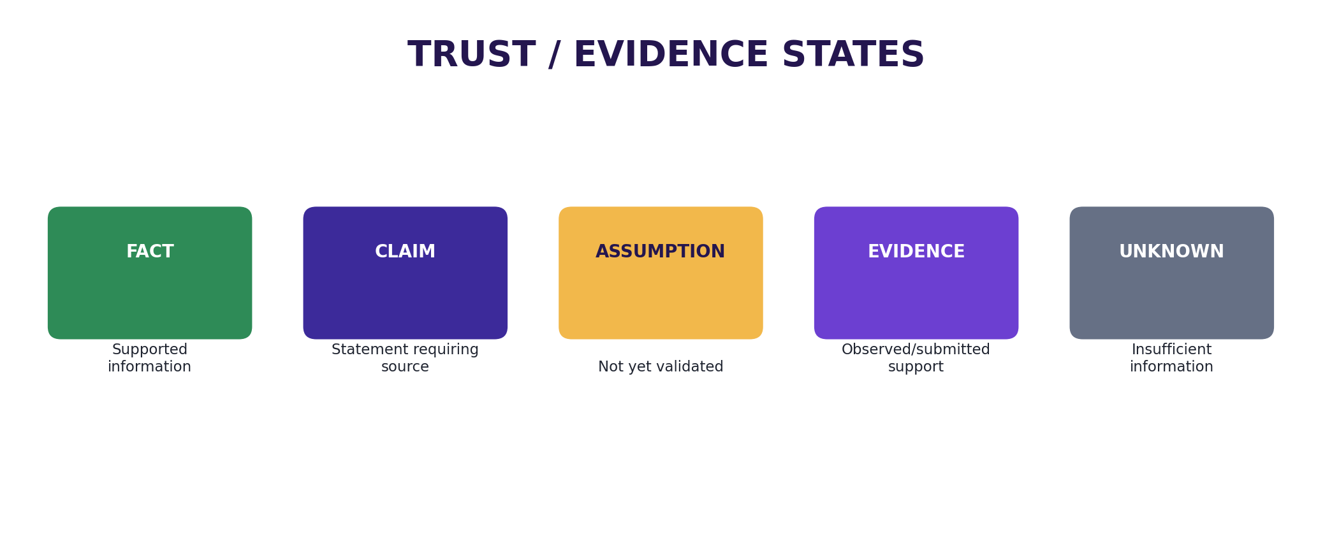
Figure 9. Trust states that can be used to prevent assumptions from being presented as verified facts.

16.1 Privacy requirements
Requirement | Acceptance condition
Consent | Consent/notice is presented before collecting relevant data at scale
Access | Users can access only records they are authorised to see
Conversations | Private AI conversations are not exposed to other users
Audit | Important records have audit fields
Retention | Retention/deletion rules are documented before production
Reporting | Users can report incorrect AI output or product problems

17. ANALYTICS AND MEASUREMENT
The playbook specifies activation, lesson completion, practice completion, simulation completion, assessment improvement, next-step click-through, weekly active learners and path completion as product analytics. fileciteturn2file5
Event | Definition / trigger
signup | Account created
assessment_started | Baseline assessment opened
assessment_completed | Baseline assessment submitted
roadmap_viewed | Roadmap opened
lesson_started | Lesson opened/started
lesson_completed | Lesson completion recorded
practice_started | Practice task opened
practice_submitted | Practice submission created
simulation_started | Simulation session started
simulation_completed | Simulation completed
assessment_submitted | Practical assessment submitted
portfolio_item_created | Evidence item saved
ai_coach_opened | AI Coach opened
next_action_clicked | Recommended next action started

Metric | Definition
Activation | % of signups who complete starting assessment and view roadmap
Lesson completion | % who finish lesson after starting
Practice completion | % who submit practical task
Simulation completion | % who complete full simulation
Assessment improvement | Change from initial to revised score where applicable
Next-step click-through | % who start recommended next action
Weekly active learners | Users returning and performing meaningful action in a week
Path completion | Users reaching defined endpoint for MVP pathway

18. ADMIN, CMS AND OPERATING MODEL
Admin object | Required controls
Career path | Create/edit/publish/archive; levels; description
Milestone | Order; objectives; linked lessons/tasks/assessment
Lesson | Text/media; resources; version; publish state
Resource | File/link; tags; owner; review date; version
Simulation | Scenario; AI role; rubric; completion condition
Assessment | Task; rubric; pass/completion rule
Rubric | Criteria; levels; version; effective date
User | Access state; journey state; support status
Analytics | Funnel, retention and pathway metrics
AI configuration | Service prompts, grounding sources and version history

18.1 Content governance
• Every published item has an owner.
• Every high-impact item has a review status.
• Retired content remains traceable in version history.
• External facts used in content should have a source record.
• AI-generated drafts require human review before becoming official curriculum.

19. CONTENT PRODUCTION SYSTEM
The playbook provides a repeatable content factory that does not require the founder to appear on camera. Each learning item should be tied to a career milestone. fileciteturn3file0
Asset | Production method | Purpose
Narrated lesson | Slides + licensed/owned narration | Teach core concept without face-to-camera
Screen demo | Screen recording | Show tools/workflows
Animation/diagram | Motion graphics | Explain frameworks/processes
Template | Editable download | Move learner into action
Scenario | Decision tree or AI role-play | Practise judgement/behaviour
Quiz | Short formative check | Confirm understanding
Practical task | Brief + rubric | Generate evidence of capability

19.1 Lesson specification
• Learning objective.
• Five-minute lesson script suitable for voice-over slides.
• Visual/slide sequence.
• Screen-demo plan.
• One worked example.
• One practice task.
• One realistic workplace scenario.
• Five-question knowledge check.
• Assessment rubric.
• Downloadable worksheet/template.
• Common mistakes.
• Next milestone.
This specification is directly based on the supplied content-creation prompt. It is a content template, not a claim that each future lesson must use identical length or media.

20. BUILD AND IMPLEMENTATION ROADMAP
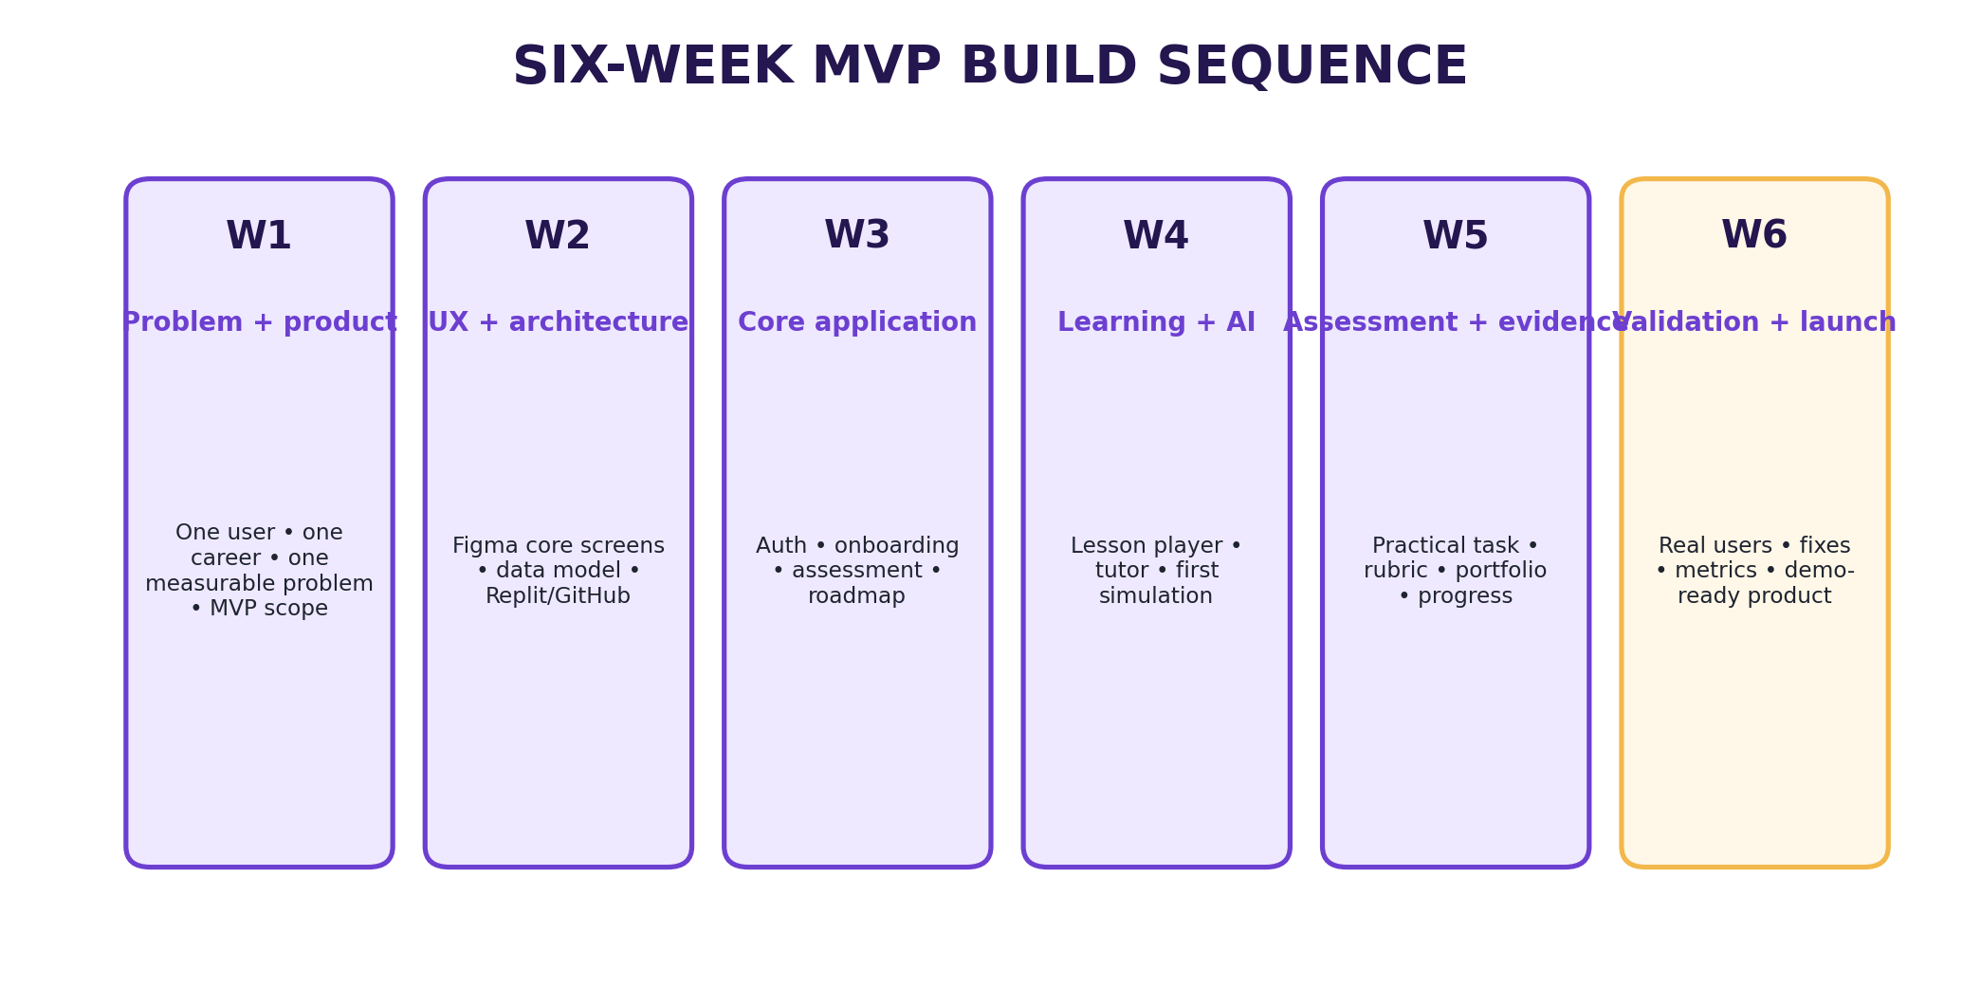
Figure 10. Six-week MVP build sequence supplied in the playbook.
Step | Workstream | Output
1 | Create product workspace | Replit project, private GitHub repository, README with purpose/scope/stack/rules.
2 | Freeze MVP | Choose one career, define journey, success metric and first 10 learning/practice items.
3 | Design screens | Figma screens: Landing, Onboarding, Dashboard, Career Path, Lesson, Practice, Simulation, Assessment, Portfolio, AI Coach.
4 | Authentication | Email sign-up/login, password reset, basic profile.
5 | Data model | Create users, careers, milestones, lessons, simulations, assessments, submissions, evidence, progress and AI conversations.
6 | Onboarding | Goal, current level, experience, preferences, weekly availability.
7 | Roadmap | Turn assessment outputs into ordered milestones stored as data.
8 | Content delivery | Lesson pages supporting narrated media, text, resources and completion.
9 | AI tutor | Ground tutor in current lesson and approved curriculum.
10 | Practical work | Task page, submission area and rubric.
11 | Simulation | One high-quality workplace scenario with role, response and feedback.
12 | Progress | Milestone completion, scores, evidence and one next action.
13 | Portfolio | Simple public/private evidence page.
14 | Venture architecture | Navigation and data objects; advanced venture features behind flag.
15 | Real-user testing | Observe actual usage.
16 | Fix weakest point | Use behaviour to improve onboarding, roadmap, lessons, simulation or assessment.
17 | Web MVP deployment | Stable web release; desktop and mobile browser testing.
18 | Native mobile | Expo/React Native using same backend.
19 | Payments | Paystack only after value proposition is proven.
20 | Controlled launch | Beta, usage tracking and early-user support.

21. TESTING AND VALIDATION PLAN
Test | Method | Success signal
Problem validation | Interview 10–20 target users | Repeatedly hear same progression problem in their own words
Usability | Observe 5–10 users completing onboarding | Most reach roadmap without explanation
Learning value | Compare first and revised submissions | Performance/clarity improves after feedback
Simulation value | Have users complete AI scenario | Users describe scenario as useful and realistic
Retention | Observe return to next milestone | Users voluntarily continue beyond one lesson
Payment signal | Test paid pathway with small group | Users make real purchase rather than only saying they would

21.1 Test protocol
• Recruit participants who match the current target segment.
• Give them a realistic goal rather than explaining every screen.
• Observe where they hesitate, abandon or ask for help.
• Record task completion and qualitative feedback.
• Do not treat positive statements alone as proof of willingness to pay.
• Convert findings into a decision register entry.
• Fix the weakest point before adding more features.

21.2 Product decision register
Assumption / decision | Evidence needed | Decision status
One career pathway is the correct MVP beachhead | User research + usage + payment | Open until tested
Users value progression more than content volume | Behaviour + interviews | Open
Practice improves perceived/useful capability | Before/after work comparison | Open
Simulation is realistic/useful | Observed completion + interviews | Open
Evidence increases product value | Portfolio usage + user feedback | Open
Users will pay for complete journey | Actual payment test | Open

22. GO-LIVE AND LAUNCH
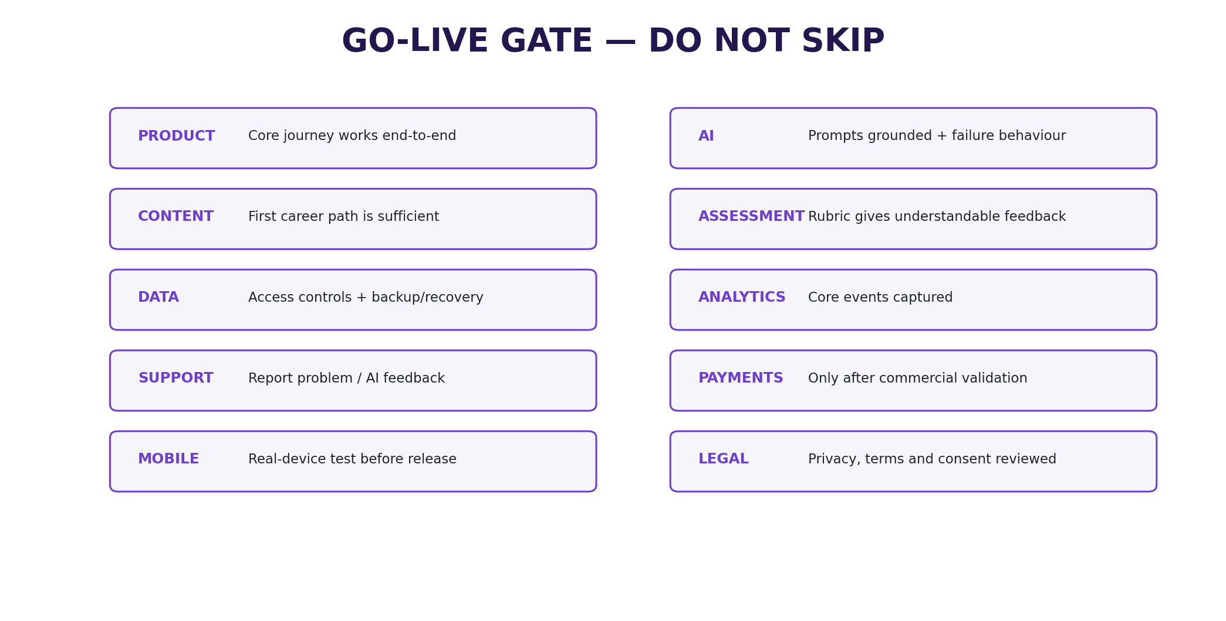
Figure 11. Go-live gate. Each area should be checked before controlled launch.
Area | Done when
Product | Core user journey works end-to-end without manual intervention
AI | Prompts are tested, grounded and have failure behaviour
Content | First career path has enough lessons/tasks to complete MVP
Assessment | Rubric gives consistent, understandable feedback
Data | User records are protected and backup/recovery approach exists
Analytics | Core product events are captured
Support | User can report a problem or incorrect AI feedback
Payments | Enabled only after commercial validation and webhook testing
Mobile | Native build tested on real devices before release
Legal | Privacy policy, terms and consent reviewed before collecting data at scale

22.1 Mobile release sequence
Stage | Action
1 | Develop/test through Expo
2 | Run internal/closed testing
3 | Fix crashes, permissions and onboarding issues
4 | Create store assets, privacy policy and app description
5 | Use authorised developer/organisation account
6 | Submit after MVP is stable
7 | Monitor releases and feedback

The playbook notes that app-store publishing involves separate developer accounts, policies and review processes. Current fees and store policies should be re-checked before submission. fileciteturn3file1

23. MONETISATION AND COMMERCIALISATION
The playbook advises against monetising too early and proposes a hybrid long-term model. These are commercial hypotheses, not validated revenue streams. fileciteturn3file9
Revenue stream | Potential approach | Timing
Freemium | Free diagnostic and limited starter journey | After MVP validation
Premium pathway | Paid full career pathway | Early commercial test
Venture pathway | Paid structured founder journey | After career engine proves useful
Cohort/institution | Licences to training organisations/employers | Later
Career coaching add-on | Human expert support | Later

COMMERCIAL DISCIPLINE
Do not build a complex subscription system before evidence that users complete the core journey and value it. Payment should follow demonstrated value, not precede it.

24. LONG-TERM PLATFORM ROADMAP
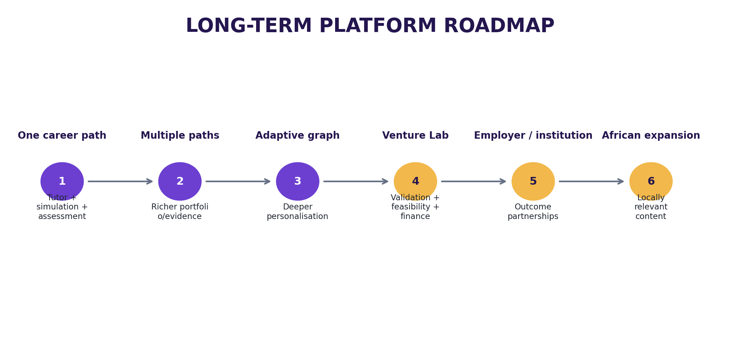
Figure 12. Long-term platform evolution from one validated pathway to broader ecosystem capabilities.
Stage | Platform evolution
Stage 1 | One career path + AI tutor + simulation + assessment
Stage 2 | Multiple career paths + richer portfolio/evidence
Stage 3 | Adaptive progression graph + deeper personalisation
Stage 4 | Venture Lab with validation, feasibility and financial modules
Stage 5 | Employer/institutional pathways and outcome partnerships
Stage 6 | Broader African expansion with locally relevant career/venture content

These stages are directly stated in the supplied playbook. The timing and breadth of each stage remain contingent on validation and resources. fileciteturn3file8

25. RISKS, DEPENDENCIES AND DECISION REGISTER
Risk/dependency | Potential effect | Control
Feature sprawl | MVP becomes too broad | Freeze MVP boundary
Unvalidated career choice | Build solves weak beachhead | Validate before deep content build
AI hallucination | Incorrect guidance | Grounding + explicit uncertainty + tests
Weak rubric | Capability claims lack credibility | Author and version rubrics
Content overload | Users consume but do not practise | Tie content to tasks
Low retention | Users abandon journey | Observe and fix weakest point
Premature payments | Commercial complexity before value | Delay Paystack integration
Privacy failure | User trust/data risk | Access controls + privacy by design
Vendor cost changes | Unexpected operating cost | Re-check current pricing before launch
App-store delay | Mobile release blocked | Stabilise web first

25.1 Dependencies
Dependency | Needed before
Selected first career | Career content build
Career template | Roadmap engine
Approved curriculum | Grounded tutor
Rubric | Assessment evaluator
Simulation scenario | Simulation agent
Content/resources | Lesson and practice release
Analytics events | Public beta
Privacy/terms language | Scaled data collection
Payment validation | Commercial build

26. DEFINITION OF DONE
The source playbook defines MVP success as a real user entering with a career goal, completing a baseline, receiving a useful roadmap, learning, performing a practical task, completing a realistic AI simulation, receiving meaningful feedback, saving evidence and understanding exactly what to do next. fileciteturn3file8
# | A new user can… | Verification
1 | Create an account | Observed test
2 | Choose a career | Observed test
3 | Complete the baseline | Observed test
4 | Receive a roadmap | Observed test
5 | Complete a lesson | Observed test
6 | Complete a practical task | Observed test
7 | Use an AI simulation | Observed test
8 | Receive rubric-based evaluation | Evaluation test
9 | Save evidence | Portfolio test
10 | See a clear next action | Dashboard test

MVP SUCCESS CONDITION
If any of the ten core actions cannot be completed reliably, the product should remain in build/test rather than expanding into additional careers, social features, job marketplace functionality or a large venture ecosystem.

27. APPENDICES AND PRODUCT TEMPLATES

Appendix A — Career pathway template
Field | Definition
Career name | Approved career title
Target level | Defined target level
Destination | What the user is working toward
Baseline criteria | What the diagnostic measures
Milestones | Ordered progression stages
Lessons | Learning items per milestone
Practice tasks | Practical work per milestone
Simulations | Scenario(s) per milestone
Assessment | Rubric and completion rule
Evidence | What is saved
Next action | How progression is determined

Appendix B — Simulation specification
Field | Definition
Scenario background | Context
Learner role | Who the user is
AI role | Client/manager/customer/colleague etc.
Goal | Desired outcome
Initial state | Starting scenario condition
Possible responses | Expected dynamic branches
Hidden state variables | Scenario state where needed
Good performance | Observable behaviours
Rubric criteria | Evaluation dimensions
Failure modes | Ways the interaction can go wrong
Completion condition | When simulation ends
Feedback format | Evidence-linked feedback

Appendix C — Assessment specification
Field | Definition
Task | What the learner must produce
Evidence required | Minimum evidence
Criteria | What is judged
Levels | Meaning of each level
Scoring | How results are represented
Feedback | Improvement guidance
Retry | Whether/when allowed
Evidence save rule | When work enters portfolio

Appendix D — Product glossary
Term | Meaning
Progression engine | The shared system that moves users through defined stages
Milestone | A meaningful stage in a journey
Capability | An ability the user is expected to demonstrate
Evidence | Work or assessment information supporting a capability state
Simulation | Controlled AI role-play used for practice
Roadmap | Ordered sequence of milestones/actions
Resource | Reusable material supporting learning or execution
Rubric | Explicit criteria used to evaluate performance
Grounding | Constraining AI responses to approved context/data
Next action | The immediate recommended task or milestone
Venture evidence | Information supporting a venture assumption or decision

Appendix E — Reference boundary
Primary source: the supplied LegendRise Career & Venture OS — Start-to-Finish Product Build Playbook. All source-supported requirements in this PRD are derived from that document. fileciteturn3file3
The PRD also introduces product-management structure—requirement IDs, acceptance conditions, decision registers, expanded resource metadata and operating controls—to make the source playbook executable. These additions are proposals unless the source explicitly establishes them.

